Business Intelligence

**CA1 - Group Assignment**

Business Intelligence Software Review

horizontal line

# Placeholder image

Group 4;

Ian Healy - L00188608

## 

## Table of Contents

1. Introduction...........................................................................................................................1
2. Business Requirements .......................................................................................................1
3. Platform Criteria – Overview ...............................................................................................2
4. Design.....................................................................................................................................2
5. Functionality ..........................................................................................................................3
6. Quality ....................................................................................................................................4
7. Ease of Use ............................................................................................................................5
8. Innovation..............................................................................................................................5
9. Reporting................................................................................................................................5
10. Zoho Analytics – Overview ..................................................................................................6
11. Zoho Analytics – Review ......................................................................................................7
12. Data Mining Potential ........................................................................................................12
13. Future Potential ……………………………………………………………………………………………………..13
14. Limitations of Zoho Analytics ...........................................................................................13
15. Conclusion ..........................................................................................................................14
16. References ..........................................................................................................................15

# Introduction

Geansaí began as a creative side project during the COVID-19 pandemic, making custom clothing pieces that found a growing audience through social media. As the business expanded, so did its challenges—especially around managing customer orders, forecasting demand, and coordinating restocks with suppliers. A major issue has been the lack of a unified system to track sales, marketing performance, and supplier status, leading to shipping delays and occasional customer dissatisfaction.

To address these challenges, we explored **Zoho Analytics** as a Business Intelligence (BI) solution. Our goal was to integrate key data sources—namely the Geansaí webstore, Google Analytics, and a supplier spreadsheet—into a single platform that provides clear, real-time insights. This report evaluates how well Zoho Analytics meets Geansaí’s needs based on criteria we set as a group: **design, functionality, quality, ease of use, innovation, data mining, and reporting**. Our findings are based on hands-on testing, group collaboration, and relevant research.

# Business Requirements

Geansaí currently relies on separate systems for operations:

* A **webstore** tracks orders and inventory but allows customers to buy items that are already out of stock.
* **Google Analytics** monitors traffic and ad performance but isn’t connected to stock data.
* A **Google Sheet**, shared with the supplier, tracks restock requests and order statuses, but isn’t integrated with the webstore.

These systems operate in silos, making it difficult to forecast demand, manage inventory accurately, or avoid duplication of supplier orders. As a result, Geansaí needs a BI tool that can:

* Offer an intuitive interface suitable for team members with little BI experience.
* Seamlessly connect to Google Sheets, Google Analytics, and the webstore.
* Help identify trends and predict demand through data mining.
* Provide dashboards and reports that consolidate all business-critical data.

Each group member focused on a different area—interface and usability, advanced features and data analytics, and long-term scalability. Together, we assessed whether Zoho Analytics could bring clarity and structure to Geansaí’s growing data needs.

# Platform criteria - overview

We are new to running a business, growing rapidly from a passion project to a successful start-up which now needs more of our attention. We are two people from a creative background and unexpectedly ended up with a semi-successful business - we are figuring this out as we go. We need the platform to be easy to navigate, whilst still giving us access to some advanced features. We are not complete novices and have been learning some SQL and Python to help us navigate our sales data more efficiently. Integrations should be easy to connect to our existing platforms.

## Design

We need our business intelligence platform to be user-friendly, easy to navigate, something which can be picked up quickly by a beginner. We work across a variety of devices, so ideally the platform should be dynamic and mobile-friendly - we use laptops, tablets, and mobile phones.

Navigation should be simple; main features should all be one or two clicks away, with more advanced features available deeper in the menus. We want the platform to be closer to navigating (for example) Facebook rather than Salesforce, which is overwhelming to a beginner. As much as possible, the platform should have drag and drop functionality for us to quickly and easily create connectors and visualizations.

As novices to the world of business intelligence, we would love for the platform to be engaging for us - we want to get excited about developing new insights into our business. Graphs and visualizations should be dynamic, offering engaging designs to easily differentiate the data we’re looking at.

## Functionality

The business intelligence platform must be able to connect to our existing datasets and platforms;

* Our webstore
* Google Analytics
* The status of our supplier orders

Our webstore is used to process and track customer orders and holds current inventory levels of stock. Customers are still able to place an order if the inventory drops to zero. However, we want to avoid receiving many backorders as there is a lead time to getting clothing produced by our supplier and we don’t want customers to have a long wait for order fulfilment. We have limited warehouse space, and do not have the budget to purchase unnecessary additional storage. Therefore, we want to leverage business intelligence to better understand our customers’ buying trends based on historical orders, predict potential periods where orders may surge, and have sufficient levels of stock in the warehouse to meet this demand.

Currently, we run some limited paid advertising. However, our primary exposure is through word of mouth and social media engagement. We leverage Google Analytics to track engagement with our brand online - but this lives in a separate platform, which means we don’t often look at it. We would love to pull in this data to a single business intelligence platform, as well as leverage it for analysis and prediction. There’s no perfect solution to predicting our customers’ future purchases, but if we can improve on the status quo, it’ll be considered a win. It generally takes our supplier a few weeks to produce new products, and ideally, we want to be able to quickly fulfil customer orders without having a huge amount of stock in the warehouse which isn’t selling and is costing us extra to store.

We use a live Google Sheets spreadsheet with our supplier to track the status of orders which we have sent them. For example, if we need our supplier to produce 15 additional items for our warehouse inventory, we add it to the spreadsheet with the product code. We call the supplier to inform them of the new order, and the supplier uses the spreadsheet to keep us informed of the status, and the date the items have been shipped to our warehouse. This helps us to understand which items are on backorder (and how many of each), as well as when the items should reach our warehouse. Once the new products arrive at the warehouse, we use a CSV file to update the current inventory levels on our webstore.

Like with our analytics, this currently lives in a separate platform. There’s a risk currently that one of us may accidentally make a duplicate order with our supplier, which means we end up with too much stock in our inventory. We would like to import the supplier order data into a business intelligence platform so that we can see current inventory (warehouse) and backorders (supplier) all in one place (see Figure 1).

We would like all these integrations to be self-service, something which we can set up ourselves without needing an external consultant or engineer. Additionally, creating the data flows should be simple, with drag and drop functionality ideally.

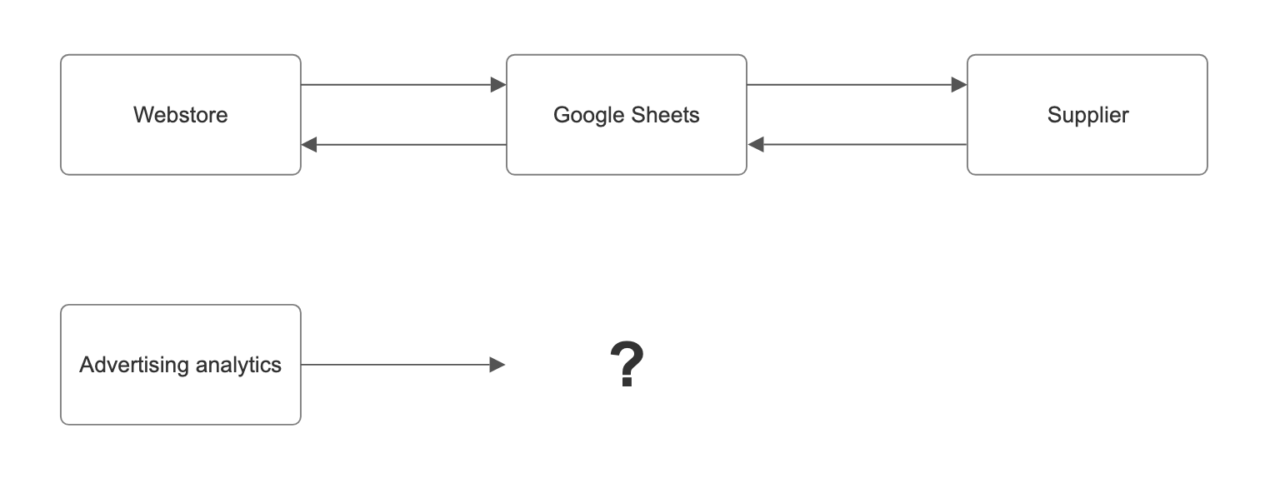

***Figure 1: Current data flow and BI integration gap***

## Quality

We would like to find a platform which is already well-established in the business intelligence space, something which is already fully featured. We are not able to work with a start-up firm and create feature requests- we need a platform which we can hit the ground running with and start quickly generating value from.

The platform should be SaaS-based and not require us to manage a server and self-host (we do not have the budget or expertise for this). We also want to use a reliable vendor where platform downtime is not going to be an issue for us. If something goes wrong or we need additional assistance, the business intelligence vendor should have a support function available to help us with troubleshooting.

Our vendor should have a knowledge base readily available for us to leverage. We are very happy to self-direct our learning and knowledge of the platform, if resources are available online for all available functionalities. This could be supporting articles, setup guides, videos of platform functionality, webinars.

## Ease of use

We would love for the platform to be easy to pick up and learn - at least the basic functions. Ideally the menus are not overwhelming with dozens of options, and menu options are grouped and nested together in a way which makes sense to an average person. The most common functions should be front and center, available within a few clicks. Where possible, integrations and data flows should be self-service and easy to connect (e.g. drag and drop functionality).

Error messages should be clear to understand and ideally provide us with guidance or a resource on how to fix it. Similarly, it would be great if the platform made suggestions on additional functions or settings based on our current usage for us to make best use of the tool.

## Innovation

We do not have a complex business, and ultimately, it’s a bigger priority for us to have a fully functioning product from day one. We are not looking to only meet some of our success criteria and work longer-term with a vendor on feature requests. However, it’s important to us that the vendor is continuing to invest in their product, and it is not going to become stagnant or get mothballed after we become a customer. We will not be looking for innovative new features from day one, but we are open to being early adopters for any new features as they become available. Ideally the user experience remains current as trends change over time - we don’t want to end up using a platform which looks and feels dated compared to everyone else.

## Reporting

The realm of business intelligence is new to us, and whilst we have some initial ideas on how to leverage our various datasets, “we don’t know what we don’t know”. We’re very open to adapting the initial reports we create, and really nothing is set in stone. As we experiment and begin to spend time using the tools, we may very well toss everything out and start from scratch having gained some experience.

We do have some initial basic requirements. With multiple datasets living in disparate platforms, we want to bring all these together into a business intelligence platform to have a single source of truth (and ideally something we can quickly look at on a phone or tablet). For purely just the daily running of the business, we want to create a dashboard which shows at a minimum.

* Current customer orders and their details (webstore)
* Current inventory broken down by item (webstore)
* Supplier backorders and their status (Google Sheets)

We also want to start analyzing past customer behaviors. This report could collate past customer orders from the webstore with our historic Google Analytics data and look for trends. This could identify regular busy periods for orders, our most loyal customers, trends in the popularity of specific items over time, and see the impact of advertising and social media on actual orders generated. Medium-term, we would also like to leverage our historical data to try and predict future demand. This will help us to make informed investments into our warehouse space, our advertising budget, and the products we bring to market.

# Zoho Analytics - overview

Zoho is a US software company, whose portfolio now includes software products across areas like sales, marketing, human resources, legal and finance (Zoho, 2024a). Zoho Analytics is just one of dozens of their products. This has pros and cons; analytics is not the sole focus of the business, but also, they have a stable, established platform and millions of customers (Zoho, 2024b). There are six main stages in the Zoho Analytics workflow; connect, prepare, analyze, visualize, collaborate and extend. Zoho allows us to connect to 500 data sources (files, feeds, apps, databases), has a range of AI tools to generate reports and insights on data, offers more than 50 visualizations for reports and dashboards, securely enables sharing of data and visualizations, and allows embedding analytics into our existing solutions using a low-code or no-code approach (Zoho, 2024c**)**. From our research, Zoho is designed to make analytics accessible to all. On paper at least, it seems to have the depth of functionality required from a data scientist, and the platform usability so that it’s manageable for a business user.

Being able to leverage a tablet or a phone is important to us, and Zoho has two apps available on both iOS and Android: one focused on dashboards, and one for business intelligence.

Zoho Analytics has a free tier with the following access:

* Supports 2 users (Account Administrator + 1 shared user) in your account
* Create a maximum of 5 Workspaces
* Supports up to 10,000 rows in your account.
* Setup up to 3 Scheduled Data Imports in your account, to periodically fetch data from publicly accessible Web URLs (website links)
* Create up to 3 SQL Query Tables in your account
* HTTPS (SSL) support for secured access.

This seems sufficient for our business needs for the foreseeable future and means there is no pressure with paying for a service while we experiment.

# Zoho Analytics - Review

We dived straight into the tool without using any guides - this was a good test of usability. We were prompted to set up my workspace in Zoho, and then immediately given the option to start importing data. We first attempted to import the supplier backorder information from Google Sheets. After authenticating my Google account and giving access to my Google Drive, we were presented with some helpful options. For example, we were able to schedule when fresh data would be imported from the spreadsheet into Zoho (see Figure 2).

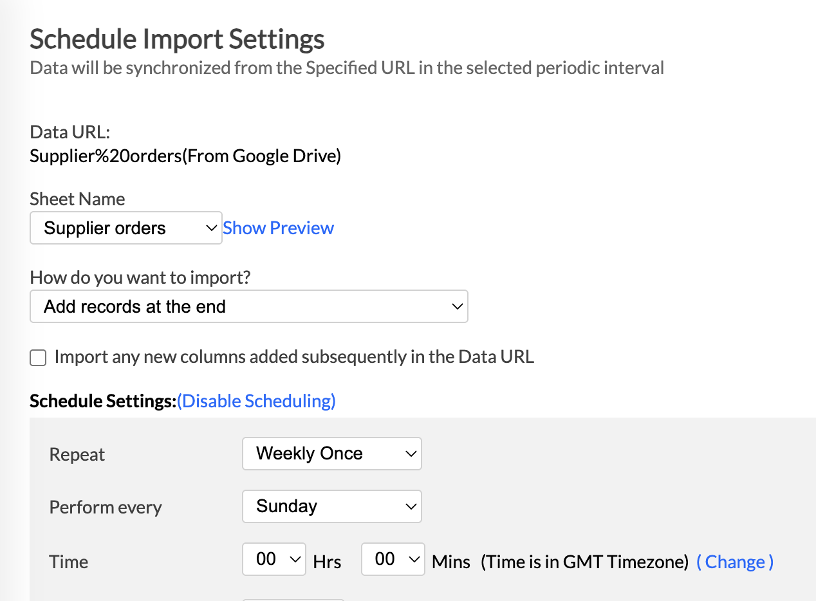

***Figure 2: Scheduled import settings***

The process was swift and easy to understand, immediately pulling data into a new table in Zoho. It was a similar process for connecting Zoho to Google Analytics and to the webstore.

The sidebar menu navigation was very simple to understand, giving us options to explore imported files, create dashboards, create reports and import new data (see Figure 3).

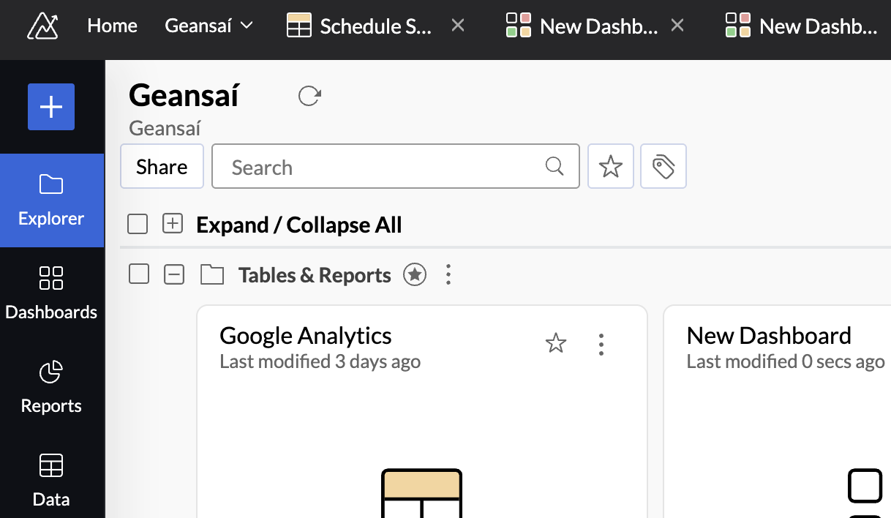

***Figure 3: Sidebar menu and workspace explorer***

Each table can be opened in Zoho, with a suite of functions for amending the data. We found the process to be simpler than Excel, but with sufficient functionality in relation to formatting, adding formulae, and filtering the data (see Figure 4).

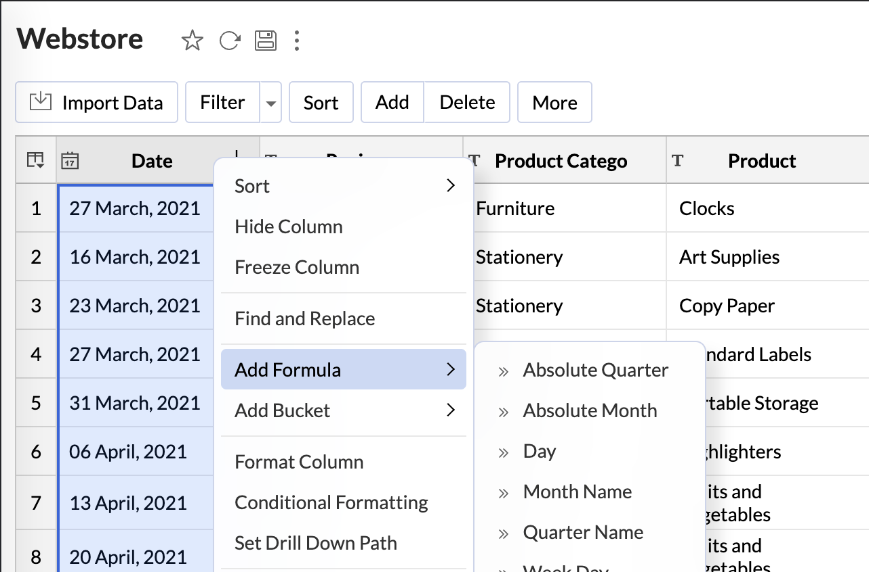

***Figure 4: Data editing and formula options***

Within Zoho, we had a powerful suite of tools to edit the design of each table without having to return to the source (e.g. Google Sheets). Whilst we did not initially understand the meaning of each option, clicking on the name gave me a helpful pop-up to add more context (see Figure 5).

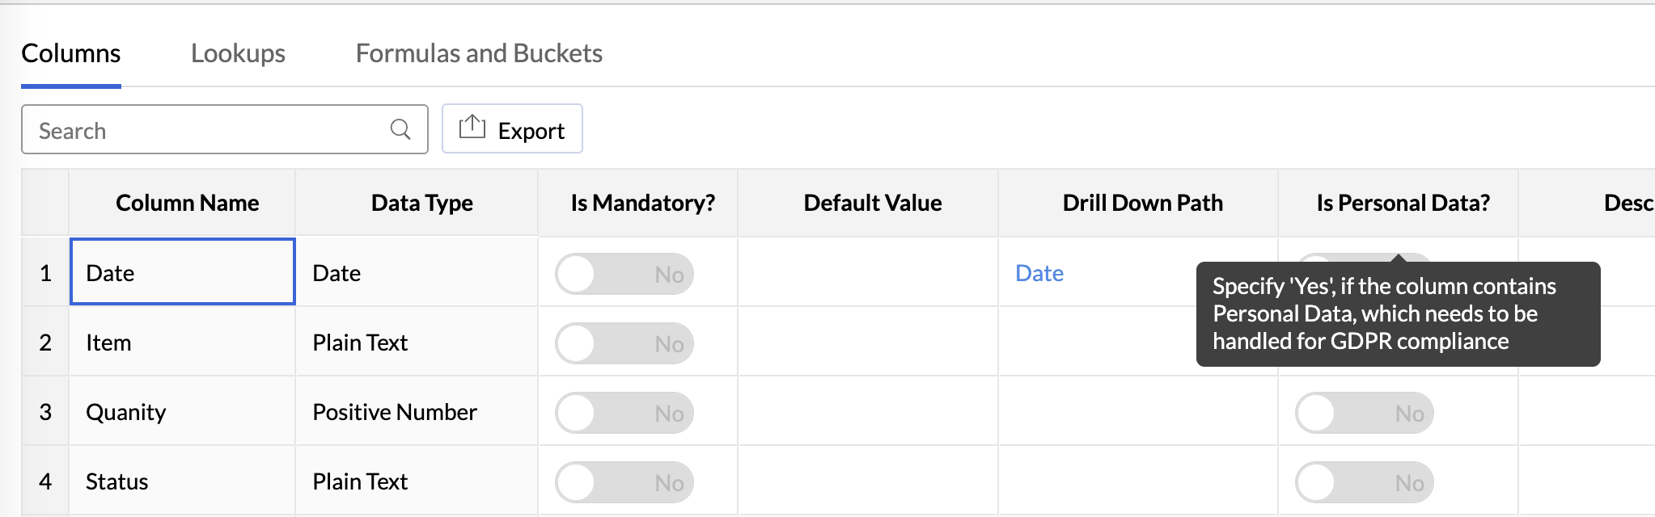

***Figure 5: Column properties and contextual help***

Each table could be shared, made public or private, could be exported to a variety of formats, and had a conversation function within the table for collaboration with others. Zoho also has functionality to import multiple datasets into the same table, although I opted instead to explore the dashboard functionality.

Dashboards were immediately intuitive in Zoho, with a simple drag and drop functionality to start displaying datasets. The sidebar contained all imported datasets and intelligently created various folders for the dozens of Google analytics datasets available to me. With 2 minutes of work, we were able to display my webstore order history, current backorders with the supplier, and some high-value analytics (see Figure 6).

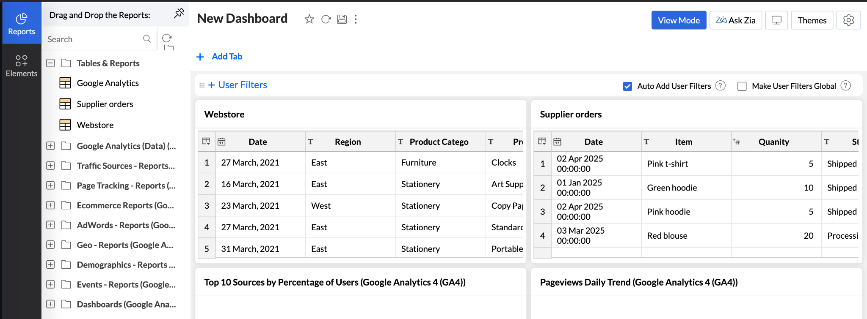

***Figure 6: Intuitive dashboard with combined datasets***

In addition to the drag and drop functionality, Zoho also supports automatically generating reports & dashboards based on the data we provide within the platform. As novices in the area of business intelligence this functionality allows for immediate visualizations to be easily created allowing us to see a high-level overview of stock & order trends which would then allow our users to create more in depth reports based on those generated by the platform. This is an excellent feature as it does give users who are not experienced in plotting their data to have these charts automatically created for them based on the data provided (see Figure 7).

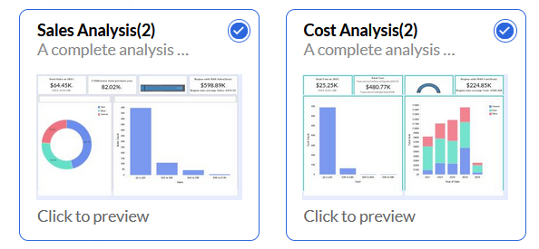

***Figure 7: Auto-generated Dashboards w/visualizations***

Each dashboard can have multiple tabs, so you can quickly and easily switch between different views and datasets without having to leave Zoho. As with the file explorer previously, dashboards have a range of functionalities and customization options; themes, exporting, filters, and a conversation area for collaboration. We were able to add a variety of additional elements to the dataset, from titles and paragraphs to images and embeddable content. We only scratched the surface of the dashboard functionality but were amazed how quickly and easily we were able to connect to disparate datasets and visualize them all in one place.

During our review, we also explored the workspace settings in Zoho. We were impressed with the customization options, allowing us to enforce formatting rules across all my datasets. The number of users is limited with a free account, and it was easy to track current user numbers here.

### Data Mining Potential

Zoho Analytics offers valuable data mining capabilities that can support more strategic decision-making at Geansaí. One of its standout features is “Ask Zia,” an AI-powered assistant that enables users to uncover trends and generate visual insights by asking plain-language questions. While our initial tests focused on basic visualizations, the real potential lies in using historical sales data, marketing metrics, and social media engagement figures to uncover patterns that can guide future planning. For example, if certain influencers consistently trigger spikes in orders, Zoho could help us identify those relationships and forecast demand more accurately. Similarly, we could examine seasonal fluctuations and predict periods of low activity in advance, allowing for more efficient inventory and staffing decisions. These features make Zoho not only a tool for visualizing data, but also a platform that encourages proactive, insight-driven business planning—an essential advantage for a growing brand like Geansaí.

**Future Potential**

As a small business venture at present the Free version of Zoho Analytics is enough for our current usage, if our business continues to grow and expand consideration has been given to upgrading to a paid version of Zoho to unlock further functionality which may be of use as the business expands. Custom Alerts can be implemented so that if specific thresholds are met in regards to any of the metrics tracked within our data that this is brought to the attention of our users within the platform or via email. With our current level of business these would not be as required due to lower quantity of data being ingested within the platform however as we expand we would need to ensure that we are aware of any significant changes both positive and negative so that we can act on those changes as quickly as possible.

In addition to the Alert functionality, we would also be able to take advantage of the increased level of data storage and reporting along with the ability to schedule additional automatic data imports we can also connect directly to our external Business Apps such as Google Analytics so that our data is dynamically synced with Zoho Analytics which would then reduce the time taken in relation to data gathering required by our users thereby allowing them more time to focus on the analysis of the data itself.

**Limitations of Zoho Analytics**

While Zoho Analytics exceeded our expectations in many areas and comfortably met our initial business requirements, it’s important to acknowledge a few potential limitations that may become relevant as our business continues to grow.

Firstly, although the free tier is generous and more than sufficient for our current needs, it comes with notable constraints. Only two users are supported (an admin, and one shared user), with a limit of 10,000 rows across all imported datasets (Zoho, 2024). This may be sufficient for our current stage, but as we accumulate more historical sales, analytics, and inventory data, we may need to upgrade to a paid tier to continue scaling our reporting.

Secondly, although the platform is intuitive for basic tasks, more advanced features like SQL queries and custom analytics require a steeper learning curve. Reviews on TrustRadius highlight that documentation for these functions can be limited, which may slow down more complex analysis (TrustRadius, 2024). As users from a creative background with limited BI experience, this could require a time investment or ongoing self-learning to fully leverage the tool’s potential.

Additionally, while Zoho Analytics does support a large number of options for plotting our data, it does require that the user self-educate on how the data would need to be presented. The platform does allow for a simple drag-and-drop approach when creating a plot however the platform does not indicate to a user directly how the data needs to be plotted in order to achieve their desired result. If the data a user has provided does not match the criteria needed to create a certain plot type the platform would simply not allow them create it but does not provide any direct feedback as to how the user has misformatted their data which does increase the learning curve for a new user.

These limitations are relatively minor in the context of our current business size and needs. However, they provide important context for how Zoho Analytics may scale with us over time and highlight areas we may need to plan for as we grow.

## Conclusion

Zoho Analytics is a solid fit for Geansaí’s current needs. It provides the tools to bring together multiple data sources, present insights clearly, and begin moving toward **data-driven forecasting**.Zoho offers a good balance of **usability, flexibility, and long-term potential**.

While we’ll eventually need to consider a paid plan and possibly invest time in learning more advanced features, the platform gives us a strong starting point. Based on our testing and group review, we believe Zoho Analytics is a valuable tool for improving inventory planning, marketing analysis, and overall decision-making at Geansaí.

# References

TrustRadius (2024) *Zoho Analytics Reviews*. Available at: https://www.trustradius.com/products/zoho-analytics/reviews (Accessed: 27 March 2025).

Zoho (2024a) About Zoho. *Zoho*. Available at: https://www.zoho.com/aboutus.html (Accessed: 31 March 2025).

Zoho (2024b) *Zoho Analytics Pricing and Features*. Zoho. Available at: https://www.zoho.com/analytics/pricing.html (Accessed: 24 March 2025).

Zoho (2024c) Zoho Analytics Features. *Zoho*. Available at: https://www.zoho.com/analytics/features.html (Accessed: 31 March 2025).